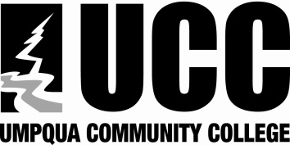

Division: Arts & SciencesClick here to enter text. Date: Click here to enter text.
Department/Program: Click here to enter text. Course Number: Click here to enter text.
Course Title: Click here to enter text.

Course Learner Outcome | Related AA/OT or Program Outcome | Related Universal Student Learner Outcome
NOTE: Enter related AA/OT or Program outcomes on Page 2.
Related AA/OT or Program Outcomes

Universal Student Learner Outcomes
Universal Outcomes:
Students who complete programs at UCC will:

- Exhibit professional skills and standards that will lead to workplace or continued academic success.

- Communicate effectively by applying appropriate listening, speaking, and writing skills both individually and as a member of a team.

- Demonstrate satisfactory academic knowledge appropriate to their educational goals.

- Identify and articulate ethical issues as they apply to personal and professional choices.

- Contribute the positive welfare of the campus, local, and broader community through engaging in diverse, cross-cultural opportunities and interactions.

- Demonstrate appropriate use of current technology as it relates to their programs of study.

- Identify professional goals that support lifelong learning, productivity, and satisfaction.

