ACCESSIBILITY CHECKLIST
Contact UCCOnline for additional information regarding any item in checklist
FORMAT | ITEMS TO CHECK | TIPS
SYLLABUS | - Digital and in an accessible format  - Includes a current disability statement  - Includes ADA compliance statement for Canvas | Disability statement and ADA compliance for Canvas can be found in the Accessibility training.
WEB-BASED  CONTENT IN CANVAS  <html> | - Color is not the sole means by which information is conveyed  - Color contrast between text and background color is sufficient  - Heading structure is followed  - Hyperlinks are have a meaningful description of where they are going to and will make sense out of context  - Images have the proper ALT description  - Lists are formatted using bullets or numbers (not manually done).  - Remove animations or check that flicker rate is lower than 2 HZ or greater than 55 Hz (approx. 3 seconds)  - Data tables include a summary, caption, and headers for rows and columns. | Use the WAVE toolbar or other freely available tools to test your web-based content.  Images:  - Decorative or non-functional images should have “null” in the ALT text  - Simple images (photos, drawings, buttons) have descriptive ALT text  - Complex images (detailed maps, flow charts, image of processes) have explanatory text next to image or a link to explanation page
VIDEO | - Include accurate and synchronized captions or script  - Video player is keyboard accessible | Both Closed Captions and a script are recommended.  Press TAB on the keyboard. You should be able to play, pause, rewind, fast forward and toggle the captions for video using only your keyboard.
AUDIO  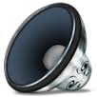 | - Transcript is provided
WORD | - Word files created in Word are accessible and can be accessed by users of assistive technology  - Heading styles are used  - Built-in formats for bulleted lists, columns and tables are used  - Images have alternate text | Run the Microsoft Word Accessibility Checker
POWERPOINT  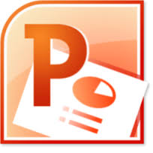 | - Word files created in Powerpoint are accessible and can be accessed by users of assistive technology  - Provide notes in the Notes section | Run the Microsoft Powerpoint Accessibility Checker
EXCEL  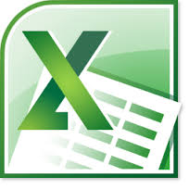 | - Did not use black cells for formatting  - Specified column headers | Run the Microsoft Excel Accessibility Checker
PDF  DOCUMENT  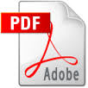 | - Create accessible PDF from Microsoft Word (Windows only) or InDesign  - Scanned items will require OCR | MS Word for Mac cannot create an accessible PDF. You must either use LibreOffice (free) or save to PDF on a Windows computer.  In Adobe Acrobat Pro and choose Full check under View, then Tools, then Accessibility.  Confirm the correct document reading order by selecting Read Out Loud in the View menu to have the document read to you.
PUBLISHER CONTENT and OUTSIDE WEBSITES | - Publisher content is verified to be accessible  - All required outside websites are verified to be accessible | Questions to ask your publisher.
For information regarding Math, Blackboard Collaborate, Google Docs or other types of content please contact:
UCCOnline 541-440-7685 or ucconline@umpqua.edu 04/22/2015

