ASUCC Student Services
For more information regarding ASUCC Student Services, stop by the ASUCC offices in the campus center anytime and speak with any of the ASUCC student leaders or visit ASUCC on the Umpqua.edu website.

Project C.A.N.S.
Project C.A.N.S. is an on-campus food pantry established by ASUCC Leadership Board. It is designed to assist students during difficult times and is a place where you can receive free, supplemental food assistance. Each box is three days of meals.
Qualifications: Any student enrolled for at least 3 credits* may access Project C.A.N.S. up to three times per term.

Backpack Program
New students who are facing difficulties purchasing basic class supplies can request assistance from the Backpack Program, established by ASUCC Leadership Board. The backpack contains a notebook, notebook dividers, paper, pencils, pens, and highlighters. Some items may vary on availability.
Qualifications: Any student enrolled for at least 3 credits* may apply for the backpack program.
To Apply for Student Services: pick up a referral slip from the Student Center/ Student Services area. Complete the referral slip and have it signed by Financial Aid (for Gas Cards, and Bus Passes). Bring the completed referral slip to the ASUCC Leadership Board offices in Riverhawk Central in the Student Center. Upon approval, student services may take 24 hours to process.
*Includes ABS credit students

Gas Voucher Program
Established by ASUCC Leadership Board, the gas card program is intended to assist students that cannot afford gas at the beginning of the term, in the period between the time school starts and financial aid is disbursed. Each voucher is in the form of a gas card.
Qualifications: Any student enrolled for at least 3 credits* may apply. Each voucher is in the form of a gas card. A student is only eligible to receive one (1) gas card per term, maximum four (4) cards per academic year. Dollar amount for gas card is calculated as follows:
Miles from Campus | Card Value in Dollars
1 to 9 | $ 5.00
10 to 19 | $ 10.00
20 to 29 | $ 15.00
30 + | $ 25.00

Free Textbook Reserve
Textbooks are a very hefty expense for college students. ASUCC sponsors a Free Textbook Reserve, located in the UCC Library. The reserve houses copies of textbooks for many (but not all) of the classes taught at UCC. The textbooks are available for use only in the Library and may not be checked out. Books have a time limit for use, but can be renewed for more time if needed.
Qualifications: Any current UCC student can access textbooks from the reserve while in the library. This privilege can be revoked if textbooks are late or damaged upon return.
First Steps: Approach Circulation in the UCC library and request to use the textbook you need.

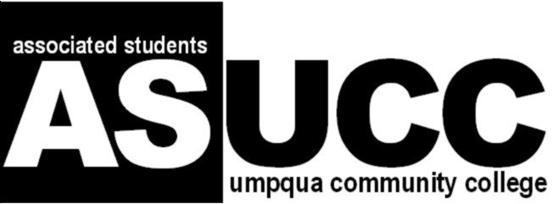
The ASUCC Leadership Team will represent all students currently enrolled at Umpqua Community College. No student shall be discriminated against on the basis of sex, race, color, national or ethnic origin, age, sexual orientation, marital status, disability, political affiliation, religion or any other status or characteristic protected by applicable state or federal law.

